**Option 8**: What are the data-ink or signal to noise ratios?

Data-Ink is a concept that was introduced by Edward Tufte. It is considered as THE guiding principle in data visualization. He stated “Above all else show the data”

1. Data-ink is the non-erasable core of a graphic.
2. Data-ink ratio =
   1. Data-ink divided by the total ink used to print the graphic.
   2. the proportion of a graphic’s ink devoted to the non-redundant display of data information.
   3. One minus the proportion of a graphic that can be erased without loss of data information.

Like signal to noise ratio in physics, which is nothing but a ratio of one possibility to another and helps us understand the odds of a particular event to happen. For example, signal to noise ratio for rain is 85 to 15 or probability of 85% will be considered favorable for rain happening. Similarly, Edward Tufte proposed this probability ration and argued that that the percentage of ink in a chart that displays data, when compared to the total ink, should be as close to 100% as possible.

To thoroughly, accurately, and clearly inform or visualize, we should identify what the intended signal is and then boost it while eliminating as much noise as possible to have better visualization. Since the data is messy, we need to carefully evaluate the data and find the right content that visualize the intent as close to 100%.

Visualization can deviate and misrepresent if:

* Data signals are good but clear understanding of the truth wasn’t the designer’s objective
* highly manipulated data replaced the actual data because it told a more convenient story, one that better supported an agenda.

We designer should have full understanding of the truth and we should never over-simplify the data that it starts telling the story we want to tell instead of actual story. We should always keep in mind that statistical models are estimates and built on assumptions which are never entirely true.

**Option 9**: What are the Gestalt Principles of Visual Perception? Give an example of each.

Gestalt Principles are important for user experience design. When we create a visualization diagram audience must be able to understand what they are seeing and should be able to find what they want. These principles are important for designer who is working on visualization because this will help in understand how should be visualize the data that will be easy for audience to understand and able to find answers they seek in the diagram.

Let’s look at 7 Gestalt principles:

1. Figure-ground: The figure-ground principle states that**people instinctively perceive objects as either being in the foreground or the background.**

Example: The Basecamp homepage has a bunch of graphics, text, forms, and other information. And because of the figure-ground principle, you can immediately tell that you should focus on the content in the white foreground areas.



Similarity: **when things appear to be similar to each other, we group them together. And we also tend to think they have the same function.**

Example: GitHub uses the similarity principle. We can immediately tell that the grey section at the top serves a different purpose than the black section, which is also separate from and different than the blue section.



Proximity: **things that are close together appear to be more related than things that are spaced farther apart.**

Example: The nearness of each image and its corresponding text communicates that they’re related to one another.

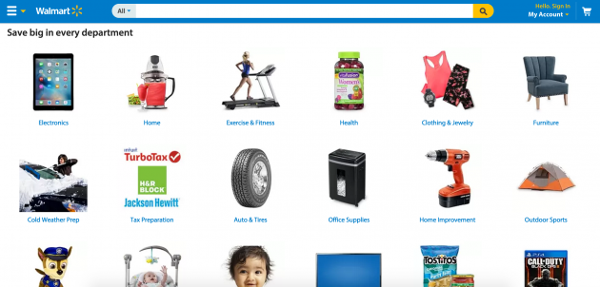

Common region: **when objects are located within the same closed region, we perceive them as being grouped together.**

Example: When we open Twitter or Pinterest, we can easily find that which photos, text, titles is related to each other. That is an example of grouping.

Continuity: **elements that are arranged on a line or curve are perceived to be more related than elements not on the line or curve.**

Example: Many retailers uses it in store and online by arranging or suggesting products based on current product.

Closure: **when we look at a complex arrangement of visual elements, we tend to look for a single, recognizable pattern.**

Example: Many companies uses it in logo design.

Focal point: **whatever stands out visually will capture and hold the viewer’s attention first.**

Example: Google search page, our focus immediately goes in searching box and button.

Reference:

1. <https://www.perceptualedge.com/blog/?p=2893>
2. <https://medium.com/plotly/maximizing-the-data-ink-ratio-in-dashboards-and-slide-deck-7887f7c1fab>
3. <https://www.usertesting.com/blog/gestalt-principles>
4. <https://www.interaction-design.org/literature/topics/gestalt-principles>